Statement of Faith

Name: _____________________________________________ Grade: ________

Bible Verse: ________________________________________________________

Fall 2025 Confirmation
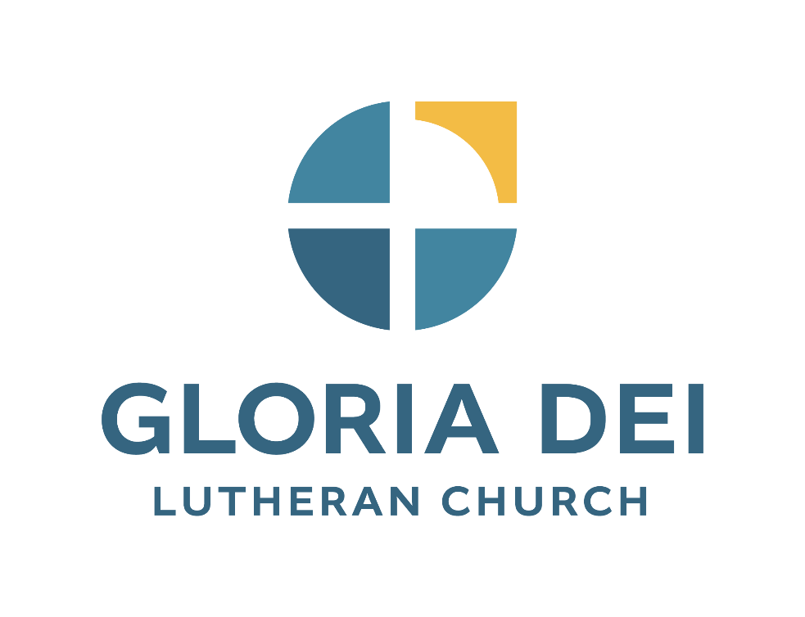

5500 E 57th Street
Sioux Falls, South Dakota
www.gloriadeisf.org
605-371-3737

Baptism and Confirmation

At your Baptism your parents, sponsors and congregation promised to provide you opportunities to worship and to learn the Lord’s Prayer, the Creed, and the Ten Commandments. They promised to place in your hands the Holy Scriptures and provide for your instruction in the Christian faith. All this has been done for you so you may live in the covenant of your Baptism and lead a godly life.

You are now about to affirm your Baptism and claim the Christian faith as your own. In your Confirmation Service the weekend of October 30th and 31st you will be asked the following question:

Do you intend to continue in the covenant God made with you in Holy Baptism:
to live among God’s faithful people,
to hear His Word and share in His supper,
to proclaim the good news of God in Christ through word and deed,
to serve all people, following the example of our Lord Jesus Christ,
and to strive for justice and peace in all the earth?

When you respond “I do, and I ask God to help and guide me.” you will be affirming your Baptism and confirming that the faith of the church is your own faith.

Statement of Faith

As you respond to the following questions you will be making statements about portions of your faith. Your responses will be the basis for the one-on-one conversation you will have with one of the pastors of Gloria Dei Lutheran Church.

“Now faith is the assurance of things hoped for, the conviction of things not seen.” Hebrews 11:1

“For by grace you have been saved through faith, and this is not your own doing; it is the gift of God.” Ephesians 2:8

My Church

Gloria Dei Lutheran Church is YOUR church.

What are some things you really like about your church?

___________________________________________________________________________________________________________

___________________________________________________________________________________________________________

___________________________________________________________________________________________________________

___________________________________________________________________________________________________________

___________________________________________________________________________________________________________

Who are some of the people with whom you have a close connection within the church?

___________________________________________________________________________________________________________

___________________________________________________________________________________________________________

___________________________________________________________________________________________________________

___________________________________________________________________________________________________________

___________________________________________________________________________________________________________

What are some things you would like to see improved in your church?

___________________________________________________________________________________________________________

___________________________________________________________________________________________________________

___________________________________________________________________________________________________________

___________________________________________________________________________________________________________

___________________________________________________________________________________________________________

What are some of the ways you have grown in your Christian Faith during the confirmation program?

___________________________________________________________________________________________________________

___________________________________________________________________________________________________________

___________________________________________________________________________________________________________

___________________________________________________________________________________________________________

___________________________________________________________________________________________________________

My Beliefs
What do you believe about:

God the Father_______________________________________________________________________________

____________________________________________________________________________________________

God the Son ________________________________________________________________________________

____________________________________________________________________________________________

God the Holy Spirit ___________________________________________________________________________

____________________________________________________________________________________________

The Church _________________________________________________________________________________

____________________________________________________________________________________________

Baptism ____________________________________________________________________________________

____________________________________________________________________________________________

Sin and Evil _________________________________________________________________________________

____________________________________________________________________________________________
Forgiveness _________________________________________________________________________________

____________________________________________________________________________________________

Grace ______________________________________________________________________________________

____________________________________________________________________________________________

Prayer _____________________________________________________________________________________
____________________________________________________________________________________________

Death ______________________________________________________________________________________

____________________________________________________________________________________________

Resurrection ________________________________________________________________________________

____________________________________________________________________________________________

My Promises

I promise God (Father, Son, and Holy Spirit) that I will ______________________________________________

___________________________________________________________________________________________________________

___________________________________________________________________________________________________________

I promise my church that I will _________________________________________________________________
____________________________________________________________________________________________
____________________________________________________________________________________________

I promise to serve the world by _________________________________________________________________

____________________________________________________________________________________________
____________________________________________________________________________________________

My Confirmation Prayer

(Write a prayer that expresses where you are in your Christian Faith right now. You may want to include words of praise to God; words of thanks for the ways your family, friends, and congregation have helped you in your faith; requests for help; and guidance for your future.)

___________________________________________________________________________________________________________

___________________________________________________________________________________________________________

___________________________________________________________________________________________________________

___________________________________________________________________________________________________________

___________________________________________________________________________________________________________

___________________________________________________________________________________________________________

___________________________________________________________________________________________________________

___________________________________________________________________________________________________________

_______________________________________________________________________________ Amen.

